6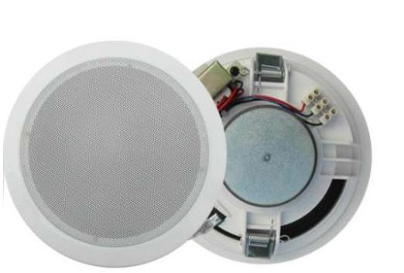" Ceiling Speaker (1.5W-3W-6W)
FCS-706
Feature:
✓ Commercial ceiling speaker with transformer.
✓ Ideal for school, office, hotel & airport background music system.
✓ Rated power output 1.5W-3W-6W at 100V.
✓ 6" full range paper driver unit.
✓ Line input 100V or 70V.
✓ ABS enclosure and metal grille in white.
✓ In-ceiling quick installation by spring clip.

Specification:
Model FCS-706
Description 6” Ceiling Speaker
Rated Power Output 1.5W-3W-6W
Line Input 100V or 70V
Frequency Response 100-15KHz
SPL(@1W/m) 93dB
Speaker Unit 6” full range paper cone
Cutout Size 170mm
Dimension 188D)×76(H)mm
Material ABS enclosure and metal grille in white
Mounting Way In-ceiling spring clip quick installation
Weight 0.7kg

Page 1 of 1 www.ftdaudio.com, info@ftdaudio.com

