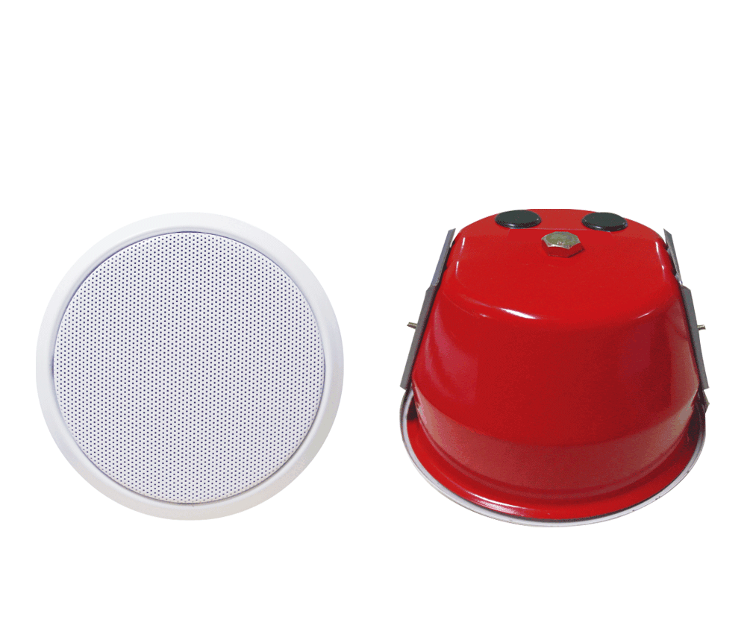
5" Fireproof Ceiling Speaker (3W-6W)
FFS-305
Feature:
- Commercial fireproof ceiling speaker with transformer.
- Ideal for school, office, hotel and airport voice evacuation and PA system.
- Compliant with the EN54-24 EVAC standard.
- Ceramic connector, fire dome, 95℃ fire-resistant cable and thermal fuse.
- Rated power output 3W-6W at 100V.
- 5" full range paper woofer.
- Line input 100V or 70V with transformer.
- With A/B two speaker cable entry.
- Metal enclosure, metal grille in white and fire dome in red.
- In-ceiling quick installation by spring clip.

Specification:
Model | FFS-305
Description | 5” Fireproof Ceiling Speaker
Rated Power Output | 3W-6W
Line Input | 100V or 70V
Frequency Response | 130-15KHz
SPL(@1W/m) | 92dB
Speaker Unit | 5” full range paper woofer
Cutout Size | 160mm
Dimension | 180(D)×135(H)mm
Material | Metal enclosure, metal grille in white and fire dome in red
Mounting Way | In-ceiling spring clip quick installation
Weight | 1.3kg

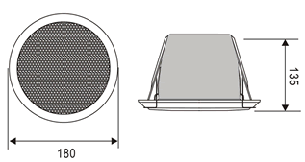
Mounting, Dimension & Side View:
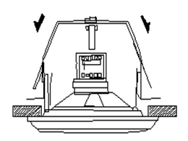
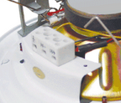

Frequency Response & SPL Diagram:
